**Power BI Documentation for Retail Data Analysis**

**1. Introduction**

Power BI is used in this project to build interactive dashboards for Retail Data Analysis. The dashboards provide actionable insights into sales trends, customer behavior, product performance, and regional analysis by consuming Gold Layer tables (Fact + Dimensions) generated through the ETL pipeline.

**Key goals of Power BI in this project:**

* Provide visual analytics for management decision-making.
* Enable self-service BI with drill-down capabilities.
* Leverage DAX (Data Analysis Expressions) for advanced KPIs.
* Gives the greater view for analysis and understands the data or trends.

**2. Data Source Integration**

* Data Source: Gold Layer Tables from the MySQL.
* Connection Mode: Import Mode (improves performance)
* Data Model: Star Schema (Fact Table: silver_retail, Dimension Tables: silver_customer, silver_product, silver_payment, silver_shipping, silver_date).

**Example**: Tables are :

**Fact Table**: silver_retail (transaction_id, transaction_date, date_id, customer_key, product_key, payment_id, shipping_id, amount, total_amount, total_purchases, order_status, ratings, feedback, processing_timestamp).

**Dimension Tables**:

* silver_customer (customer_id, name, email, address, phone, city, state, zipcode, country, age, gender, income, customer_segment).
* silver_product (product_id, products, product_category, product_brand, product_type).
* silver_payment (payment_id, payment_method, order_status).
* silver_shipping (shipping_method ,shipping_id).
* silver_date (date_key, year, month, day, day_of_week).

**3. Data Modeling in Power BI**

Established relationships:

* silver_retail.customer_key → silver_customer.customer_key
* silver_retail.product_key → silver_product.product_key
* silver_retail.date_id → dim_date.date_key
* silver_retail.payment_id → silver_payment.payment_id
* silver_retail.shipping_id → silver_shipping.shipping_id

Relationship Type: Many-to-One (Fact → Dim)

**4. KPIs and DAX Measures**

Avg age of customers

Avg age of Customers = AVERAGE('retail_analysis_db silver_customer'[age])

Avg rating by brand

Avg Rating by brand = AVERAGE('retail_analysis_db silver_retail'[ratings])

Avg rating by category

Avg Rating by Category =

AVERAGEX(

VALUES('retail_analysis_db silver_product'[product_category]),

CALCULATE(AVERAGE('retail_analysis_db silver_retail'[ratings]))

)

Avg revenue per Transaction

Avg Revenue per Transaction = DIVIDE([Total Sales],[Total Transactions],0)

Cancelled Orders %

Cancelled Orders % =

DIVIDE(CALCULATE([Orders by Status],'retail_analysis_db silver_retail'[order_status] <> "Delivered",'retail_analysis_db silver_payment'[order_status] <> "shipped"),[Orders by Status],0)*100

Feedback Count

Feedback Count = COUNT('retail_analysis_db silver_retail'[feedback])

Orders by Status

Orders by Status = COUNTROWS('retail_analysis_db silver_retail')

Processing Orders %

Processing Orders % =

DIVIDE(

CALCULATE([Orders by Status], 'retail_analysis_db silver_retail'[order_status] = "Processing"),

[Orders by Status],

0

) * 100

Products Ratings 4Plus

Products Ratings 4plus =

DIVIDE(

COUNTROWS(FILTER('retail_analysis_db silver_retail','retail_analysis_db silver_retail'[ratings]>=4)),

COUNTROWS('retail_analysis_db silver_retail'),0)*100

Shipped Orders %

Shipped Orders % =

DIVIDE(

CALCULATE([Orders by Status], 'retail_analysis_db silver_retail'[order_status] = "Shipped"),

[Orders by Status],

0

) * 100

Total Customers

Total Customers = DISTINCTCOUNT('retail_analysis_db silver_customer'[customer_id])

Total Sales

Total Sales = SUM('retail_analysis_db silver_retail'[total_amount])

Total Transactions

Total Transactions = COUNT('retail_analysis_db silver_retail'[transaction_id])

**5. Visualizations and Dashboards**

## **VIEW 1: Customer & Sales Overview**

### **KPIs (Cards)**

1. Total Customers
2. Average Age of Customers
3. Total Sales
4. Total Transactions
5. Average Revenue per Transaction

### **Customer Analysis**

* **Table**: Customer Name, Age, Gender, City, Total Amount spent
* **Pie Chart**: Sales by Customer Segment
* **Bar Chart**: Top 5 Customers by Total Purchases
* **Slicer**: Customer Segment

### **Sales Trends & Geography**

* **Line Chart**: Monthly Sales Trend
* **Map**: Total Sales by Country & State
* **Bar Chart**: Sales Trend split by Payment Method

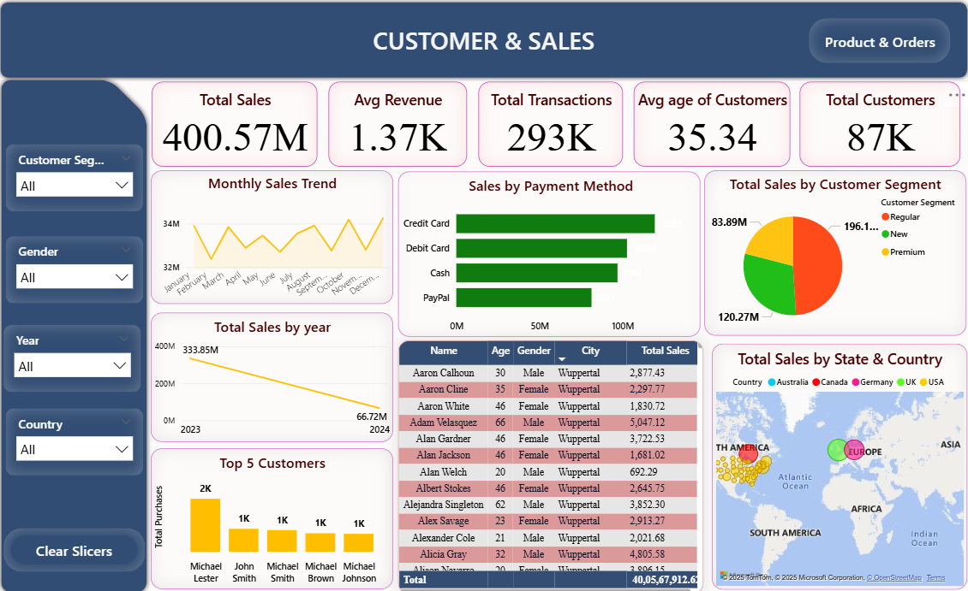

## **VIEW 2: Product, Orders & Feedback Overview**

### **Product & Brand Analysis**

1. **Bar Chart**: Sales Amount by Product Category
2. **Matrix**: Product Category → Product Type → Sales Amount
3. **Bar Chart**: Top 10 Best-Selling Products by Revenue
4. **Bar Chart**: Average Ratings by Product Brand
5. **KPI**: % of Products with Ratings ≥ 4

### **Order & Shipping Analysis**

* **Stacked Bar Chart**: Order Status by Shipping Method
* **KPI**: % of Orders Shipped vs Processing vs Canceled
* **Table**: Top 5 Shipping Methods used

### **Feedback & Ratings**

* **Pie Chart**: Feedback distribution (Excellent, Average, Bad, etc.)
* **Bar Chart**: Average Ratings by Product Category
* **Slicer**: Ratings (1–5)

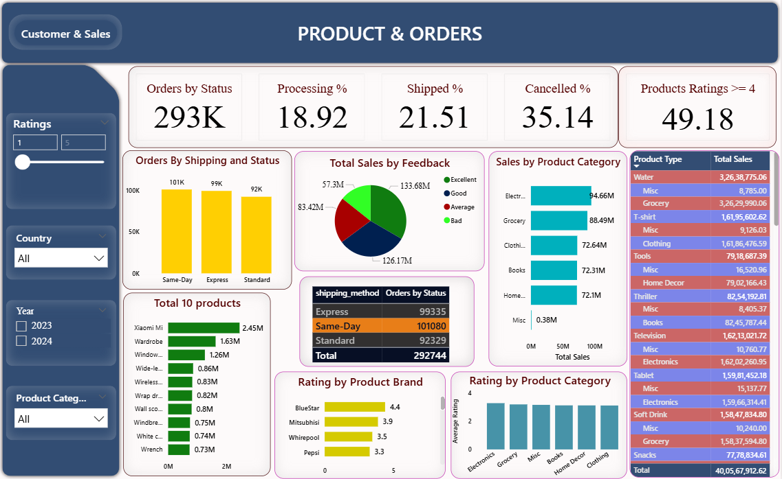

**6. Advanced Features Used**

* Slicers & Filters: Ratings, Year, Country, Customer Segment, Product Category
* Tooltip Pages: Showing extra details on hover.
* Page Navigation: Button to move from one page to another.

**7. Conclusion**

Power BI added the final analytical layer in the Retail Data Analysis, enabling data-driven decision-making. With its real-time dashboards, DAX-powered KPIs, and advanced visualizations, it bridged the gap between raw data and actionable insights.